Abstract

With SQL Server 2008 and SQL Server 2008 R2 End-of-Support, Azure Stack can help our customers modernize their existing On-Premise workloads in a phased approach.  
  
  
azseospatterns@microsoft.com

SQL 2008 and SQL 2008 R2 migration to Azure Stack

Tools and guidance to Lift and Modernize

Contents

Engagement process: 3

Jumpstart your knowledge with these online resources 3

Azure Stack Considerations 4

When should I consider using Azure Stack? 4

When shouldn’t I consider using Azure Stack? 4

ESO Paths 5

Things to remember when migrating to Azure Stack 6

VM issues that may need remediation pre/post migration to Azure Stack 6

Tools 8

SQL Best Practice Check 8

Azure Migrate 11

You can also use 12

When using the Azure Monitor MAP solution, once you’ve migrated your solution to Azure Stack you can use the same tool on Azure Stack as well ( 12

Microsoft Assessment and Planning 12

Data Migration Assistant 12

Pssdiag/Sqldiag/DiagManager 14

SQL Nexus 14

Database Experimentation Assistant (DEA) 15

Performance Analysis Tool (PAL) 16

Business Continuity SQL 2008/R2 17

Transactional Replication 17

Database Mirroring 18

Log Shipping 18

Backup and Restore 19

Architectures 20

On-Premise to AzS Lift and Modernize 20

AzS to AzS HA 21

AzS to AzP Hybrid 22

AzS to AzP Backup 23

AzS to Azure Services 24

Art of the Possible 25

Always On Availability Group 25

Backup to Azure Storage Blob 25

Engagement process:

## Jumpstart your knowledge with these online resources

* [Database Migration Guide](https://datamigration.microsoft.com/scenario/sql-to-sqlvm)
* [How to provision a Windows SQL Server virtual machine in the Azure portal](https://docs.microsoft.com/en-us/azure/virtual-machines/windows/sql/virtual-machines-windows-portal-sql-server-provision)
* [What is SQL Server on Azure Virtual Machines? (Windows)](https://docs.microsoft.com/en-us/azure/virtual-machines/windows/sql/virtual-machines-windows-sql-server-iaas-overview)

# Azure Stack Considerations

## When should I consider using Azure Stack?

* SQL Server 2008/R2 end-of-support migration path
* Workloads with custom regulatory requirements
* Workloads with custom privacy requirements
* Workloads with latency requirements that can’t be met in an Azure Region
* When you are already using Azure Stack for other hybrid applications

## When shouldn’t I consider using Azure Stack?

* When VM sizes and performance do not map to Azure Stack VM sizes and performance
* For some very large / storage intensive workloads
* Very high IOPS requirements for the workloads
* Bandwidth limitations for North/South Network traffic

## ESO Paths

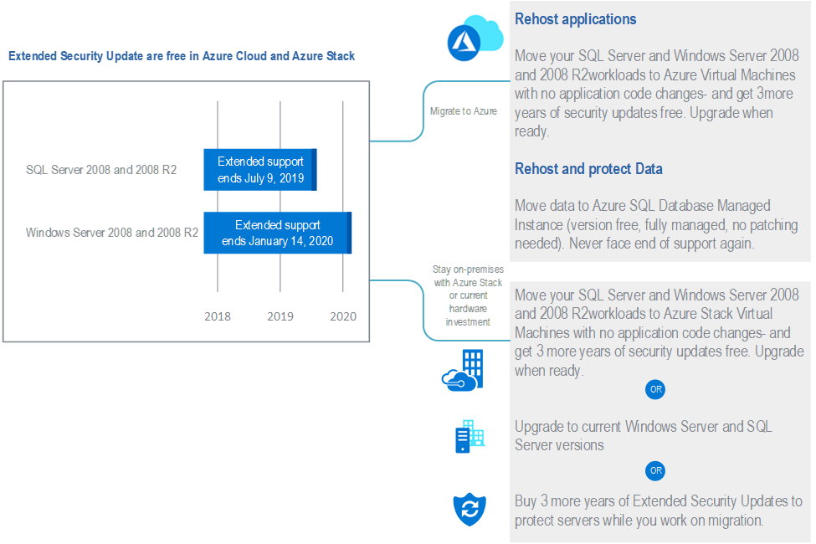

# Things to remember when migrating to Azure Stack

* Connectivity
  + Think Hybrid first – both from a connectivity, scale, and overall solution standpoint
  + Ensure all the servers that comprise that application can move together (so networking isn’t an issue)
  + Assess Connectivity and ensure applications can be accessed in the same way
  + If all the servers which create an application are moved in the same time, this simplifies networking requirements.
  + Number of VPNs and connectivity points – understand the considerations for [networking](https://docs.microsoft.com/en-us/azure/azure-stack/user/azure-stack-network-differences) and [VPN Gateways](https://docs.microsoft.com/en-us/azure/azure-stack/user/azure-stack-vpn-gateway-about-vpn-gateways#estimated-aggregate-throughput-by-sku)
  + Modernize while migrating, consider distributing the solution across Azure + Azure Stack
  + Where possible, modernize parts of the applications through containers, or moving directly to PaaS services
* HA and BCDR
  + Consider HA requirements for the SQL servers and validate the migration starting with a small deployment
  + WS2008R2 and SQL2008 have certain limitations (no CSV, no AlwaysOn, etc)
* Check and validate the activation methods for Windows Server 2008 R2 and SQL 2008 on Azure Stack

# VM issues that may need remediation pre/post migration to Azure Stack

Ensure that once a VM is migrated to Azure Stack that the [Azure VM Agent](https://docs.microsoft.com/en-us/azure/virtual-machines/extensions/agent-windows) is installed and running. If you are using a 3rd party migration tools, ensure that the tool takes this into account and installs the agent. The installation of the Azure VM Agent needs to be installed either prior to migration or once the VM is running within in Azure Stack.

The VM Agent provides our support teams access to help the customer in specific support scenario’s and enables Azure Stack to install [other VM Extensions](https://docs.microsoft.com/en-us/azure/virtual-machines/extensions/features-windows) for other services such as Azure Backup, as well as operations like “password reset”. Additionally, the VM Agent provides telemetry for all the installed Azure components.

The VM Agent requires that .NET 4.0 Framework is installed

**Important for the field to know**

* Based on current documentation **WS2008 is** **not supported to run the VM Agent,** [**see here**](https://support.microsoft.com/en-us/help/4078134/azure-extension-supported-operating-systems). This could have significant impact for any WS2008 workloads and gaining effective support from Premier in certain scenario’s (i.e. password reset) – this issue has been raised and we are waiting on additional guidance.
* When installing the VM Agent on WS2008R2 system you will be required to install the .NET Framework 4.0 prior to installing the VM Agent. Current version of the VM Agent is 2.7.41491

Once installed, verify in Services the Agent and Telemetry services are started

# Tools

Many of the tools covered below are also described in the “[Migrate SQL Server to SQL Server on Azure Virtual Machines](https://datamigration.microsoft.com/scenario/sql-to-sqlvm?step=1)” guide. As noted in the article, the same steps apply for Azure and Azure Stack VMs. Of course, there are other types of considerations which need to be taken into account – please review the “Migration Practice and Patterns” document to ensure you’ve covered the right questions.

## SQL Best Practice Check

Baseline SQL instance script**,** since this tool is run on the individual SQL server, it is less “invasive” than using the MAP and or Movere tools. However, the output of the script is “raw text” and will require a little effort to extract the necessary information to provide an analysis and inventory of the environment.

The latest script can be found here: <https://github.com/Microsoft/tigertoolbox/tree/master/BPCheck>

To help aid in reviewing the output of script, the below PowerShell commands can be run on the output files to help aid in sifting through the data:

Select-String -Path * -Pattern 'Information Machine' -Context 2, 3 | Export-Csv -Path C:\Users\yourusername\Desktop\windowsinfo.csv

Select-String -Path * -Pattern 'Cores2Socket_Ratio' -Context 2, 3 | Out-File -FilePath C:\Users\yourusername\Desktop\cores.txt

Select-String -Path * -Pattern 'Information Instance' -Context 2 | select-object -property Line | Export-Csv -Path C:\Users\yourusername\Desktop\sqlinfo.csv

**IMPORTANT pre-requisites to run the script**

* + Only a sysadmin/local host admin will be able to perform all checks.
  + If you want to perform all checks under non-sysadmin credentials, then that login must be:
  + Member of serveradmin server role or have the ALTER SETTINGS server permission;
  + Member of MSDB SQLAgentOperatorRole role, or have SELECT permission on the sysalerts table in MSDB;
  + Granted EXECUTE permissions on the following extended sprocs to run checks: spOACreate, spOADestroy, spOAGetErrorInfo, xpenumerrorlogs, xpfileexist and xpregenumvalues;
  + Granted EXECUTE permissions on xp_msver;
  + Granted the VIEW SERVER STATE permission;
  + Granted the VIEW DATABASE STATE permission;
  + A xp_cmdshell proxy account should exist to run checks that access disk or OS security configurations.
  + Member of securityadmin role, or have EXECUTE permissions on sp_readerrorlog.
  + Otherwise some checks will be bypassed and warnings will be shown.
  + Powershell must be installed to run checks that access disk configurations, as well as allow execution of unsigned scripts.

Running the Script

The script is a T-SQL script and can be run remotely on a machine using PowerShell and the SQL CMD to execute the script. There is little performance impact on the system since the script is reading the metadata of the SQL instance. The only known performance impact in running the script are the two following conditions:

If the disk fragmentation parameter is set to on, then this will enable a read lock on the index, thus queuing operations for production access to the index while the script runs. Since we are looking to migrate to a new platform in this process, the need to determine the disk fragmentation is not needed.

The script stores its results in the temp disk, if there are current issues with temp disk performance, then this should be remediated prior to running the script.

*From the read me in zip file:*

**BPCheck** - SQL Best Practices and Performance checks

**Purpose:** Checks SQL Server in scope for some of most common skewed Best Practices and performance issues. Valid from SQL Server 2005 onwards. By default all databases in the SQL Server instance are eligible for the several database specific checks, and you may use the optional parameter to narrow these checks to specific databases.

All checks marked with * can be disabled by @ptocheck parameter. Check the PARAMETERS.md file or script header for all usage parameters.

Contains the following information:

- Uptime

- Windows Version and Architecture

- HA Information

- Linked servers info

- Instance info

- Buffer Pool Extension info

- Resource Governor info

- Logon triggers

- Database Information

- Database file autogrows last 72h

- Database triggers

- Enterprise features usage

- System Configuration

And performs the following checks:

- Processor

- Number of available Processors for this instance vs. MaxDOP setting

- Processor Affinity in NUMA architecture

- Additional Processor information

- Memory

- Server Memory

- RM Task *

- Clock hands *

- Buffer Pool Consumers from Buffer Descriptors *

- Memory Allocations from Memory Clerks *

- Memory Consumers from In-Memory OLTP Engine *

- Memory Allocations from In-Memory OLTP Engine *

- OOM

- LPIM

- Pagefile

- Pagefile

- I/O

- I/O Stall subsection (wait for 5s) *

- Pending disk I/O Requests subsection (wait for a max of 5s) *

- Server

- Power plan

- NTFS block size in volumes that hold database files <> 64KB

- Disk Fragmentation Analysis (if enabled)

- Cluster Quorum Model

- Cluster QFE node equality

- Cluster NIC Binding order

- Service Accounts

- Service Accounts Status

- Service Accounts and SPN registration

- Instance

- Recommended build check

- Backups

- Global trace flags

- System configurations

- IFI

- Full Text Configurations

- Deprecated and Discontinued feature usage

- Default data collections (default trace, blackbox trace, SystemHealth xEvent session, spserverdiagnostics xEvent session) *

- Database and tempDB

- User objects in master

- DBs with collation <> master

- DBs with skewed compatibility level

- User DBs with non-default options

- DBs with Sparse files

- DBs Autogrow in percentage

- DBs Autogrowth > 1GB in Logs or Data (when IFI is disabled)

- VLF

- Data files and Logs / tempDB and user Databases / Backups and Database files in same volume (Mountpoint aware)

- tempDB data file configurations

- tempDB Files autogrow of equal size

- Performance

- Perf counters, Waits and Latches (wait for XXs) *

- Worker thread exhaustion *

- Blocking Chains *

- Plan use ratio *

- Hints usage *

- Cached Query Plans issues *

- Declarative Referential Integrity - Untrusted Constraints

- Indexes and Statistics

- Statistics update *

- Statistics sampling *

- Hypothetical objects *

- Row Index Fragmentation Analysis (if enabled) *

- CS Index Health Analysis (if enabled) *

- XTP Index Health Analysis (if enabled) *

- Duplicate or Redundant indexes *

- Unused and rarely used indexes *

- Indexes with large keys (> 900 bytes) *

- Indexes with fill factor < 80 pct *

- Disabled indexes *

- Non-unique clustered indexes *

- Clustered Indexes with GUIDs in key *

- Foreign Keys with no Index *

- Indexing per Table *

- Missing Indexes *

- Naming Convention

- Objects naming conventions

- Security

- Password check

- Maintenance and Monitoring

- SQL Agent alerts for severe errors

- DBCC CHECKDB, Direct Catalog Updates and Data Purity

- AlwaysOn/Mirroring automatic page repair

- Suspect pages

- Replication Errors

- Errorlog based checks

- System health checks

## Azure Migrate

While Azure Migrate doesn’t fully support Azure Stack as a target, it can provide valuable insights into the environment and structure of the applications. There are 3rd party tools (like Cloudbase’s Coriolis - <https://www.youtube.com/watch?v=ytRW034iueE>) which can use the Azure Migrate Assessment directly to map the VM sizes and such on Azure Stack.

* Discover on-premises VMs and app dependencies
* Mitigate VM migration issues with built-in guidance
* Adjust and optimize cloud resources based on utilization
* Get tool recommendations to use for migration
* View dependencies to group VMs effectively for migration

<https://docs.microsoft.com/en-us/azure/migrate/migrate-overview>

You can also use [Azure Monitor for VMs MAP](https://docs.microsoft.com/en-us/azure/azure-monitor/insights/vminsights-maps) to view and discover your application components, as well as gather insights around the performance of the networking aspects of your apps.

When using the Azure Monitor MAP solution, once you’ve migrated your solution to Azure Stack you can use the same tool on Azure Stack as well (<https://aka.ms/azstackupdatemgmt>) to continue monitoring the performance and validate the proper communication is in place, as well as configure Update and Track Changes that happen in your environment.

## Microsoft Assessment and Planning

The Microsoft Assessment and Planning Toolkit makes it easy to assess your current IT infrastructure for a variety of technology migration projects

<https://www.microsoft.com/en-us/download/details.aspx?id=7826>

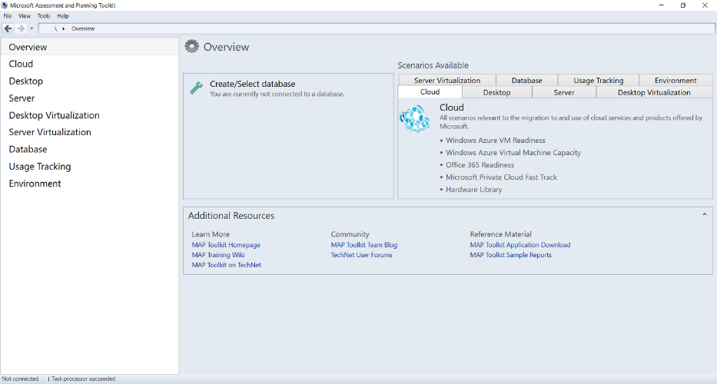

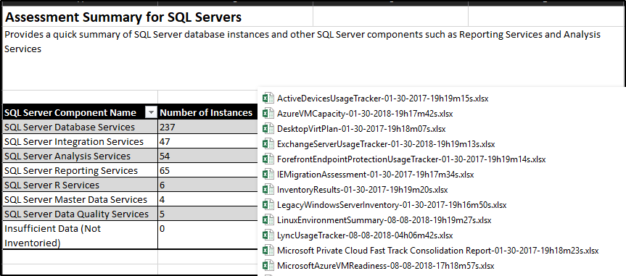

## Data Migration Assistant

SQL Migration tool/service

<https://docs.microsoft.com/en-us/sql/dma/dma-overview?view=sql-server-2017>

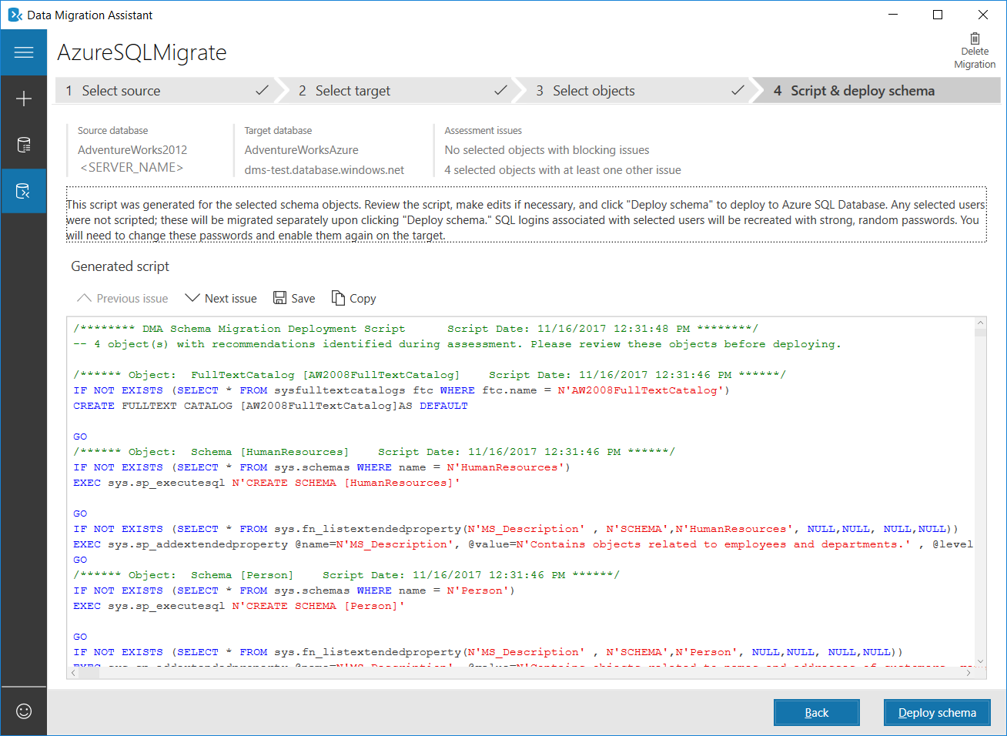

## 

## Pssdiag/Sqldiag/DiagManager

Digging deep intoperformance and benchmarking SQL instance metrics

**Documentation:**

<https://github.com/Microsoft/DiagManager/wiki/Getting-Started>

<https://github.com/Microsoft/DiagManager>

<https://msdn.microsoft.com/en-us/library/aa175399(sql.80).aspx>

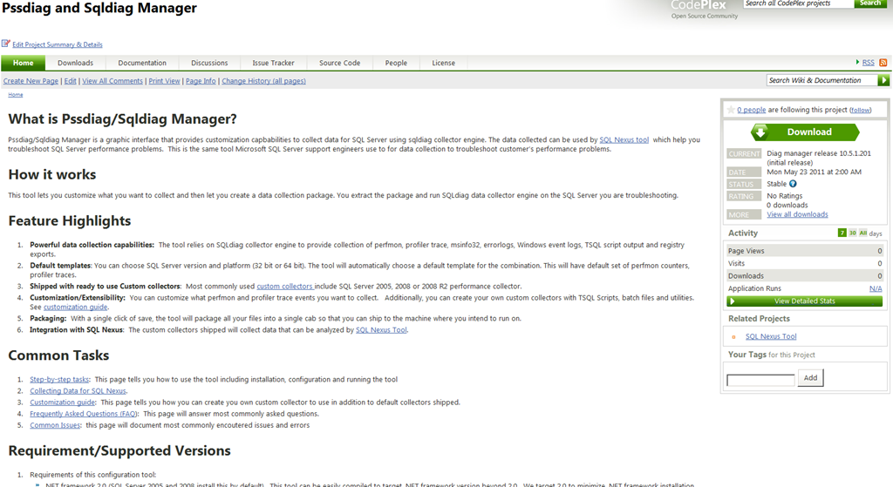

## SQL Nexus

Used to read output from DiagManager

<https://github.com/Microsoft/SqlNexus/blob/master/README.md>

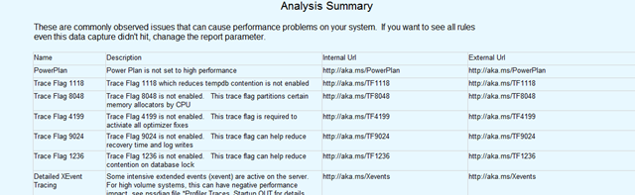

## Database Experimentation Assistant (DEA)

Database Experimentation Assistant (DEA) is a new A/B testing solution for SQL Server upgrades. It will assist in evaluating a targeted version of SQL for a given workload.

<https://blogs.msdn.microsoft.com/datamigration/2018/08/06/release-database-experimentation-assistant-dea-v2-6/>

A/B Testing Architecture

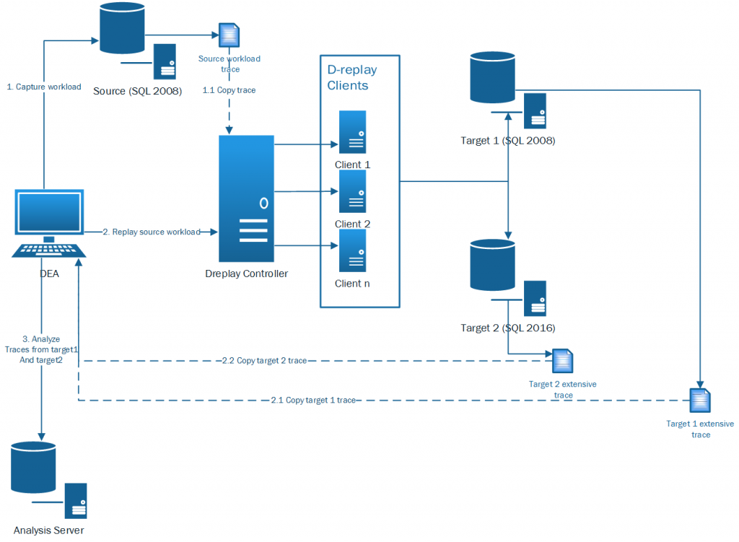

## Performance Analysis Tool (PAL)

The PAL (Performance Analysis of Logs) tool is a powerful tool that reads in a performance monitor counter log and analyzes it using known thresholds. Thresholds files for most of the major Microsoft products such as IIS, MOSS, SQL Server, BizTalk, Exchange, and Active Directory.

<https://github.com/clinthuffman/PAL>

<https://blogs.technet.microsoft.com/askperf/2009/04/10/two-minute-drill-performance-analysis-of-logs-tool-pal/>

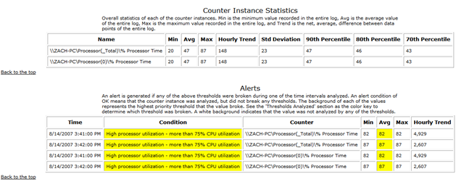

# Business Continuity SQL 2008/R2

Business continuity is essential to maintaining mission critical business functions in the event of an unplanned outage or catastrophic disaster. Business continuity has 3 key elements to consider when planning a strategy: Resilience, Recovery, Contingency. Below are the business continuity configurations available within SQL Server 2008/R2.

[High Availability with SQL Server 2008](https://docs.microsoft.com/en-us/previous-versions/sql/sql-server-2008/ee523927(v%3dsql.100))

[Planning for Disaster Recovery](https://docs.microsoft.com/en-us/previous-versions/sql/sql-server-2008/ms178094%28v%3dsql.100%29)

## Transactional Replication

MSDN Article: [SQL Server Replication](https://docs.microsoft.com/en-us/previous-versions/sql/sql-server-2008/ms151198(v=sql.100)), [Transactional Replication](https://docs.microsoft.com/en-us/sql/relational-databases/replication/transactional/transactional-replication?view=sql-server-2017)

Replication allows data to be duplicated from one database to another using the transaction log, Agents and a distribution database. Transactional replication copies incremental changes for near real-time consistency between *Publisher* and *Subscriber*.

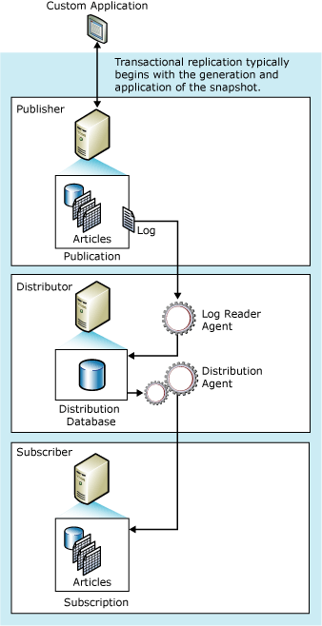

Figure 1: Transactional Replication

## Database Mirroring

MSDN Article: [Database Mirroring Overview](https://docs.microsoft.com/en-us/previous-versions/sql/sql-server-2008/ms189852(v=sql.100))

Database mirroring is a data redundancy and high-availability option within the SQL Server engine. It provides a per-database redundancy by transferring data between a *principal* and *mirror* servers on a transactional basis. Database mirroring has 3 operating modes that will determine the level of business continuity available: high-safety, high-performance, high-safety with automatic failover.

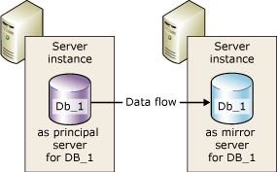

Figure 2: Data redundancy

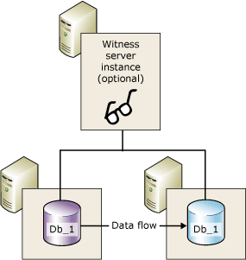

Figure 3: High availability with Witness server

## Log Shipping

MSDN Article: [Log Shipping](https://docs.microsoft.com/en-us/previous-versions/sql/sql-server-2008/bb895393(v%3dsql.100))

Log Shipping is the process of continually taking backups of the *primary* database’s transaction log then copying and restoring it to the *secondary* database(s).

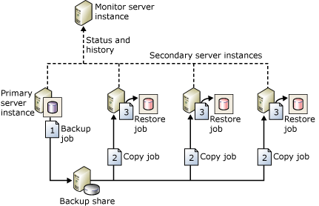

Figure 4: Scaled log shipping configuration

## Backup and Restore

MSDN Article: [Introduction to Backup and Restore Strategies in SQL Server](https://docs.microsoft.com/en-us/previous-versions/sql/sql-server-2008/ms191239%28v%3dsql.100%29), [Backup Overview (SQL Server)](https://docs.microsoft.com/en-us/previous-versions/sql/sql-server-2008/ms175477(v%3dsql.100)), [Restore and Recovery Overview (SQL Server)](https://docs.microsoft.com/en-us/previous-versions/sql/sql-server-2008/ms191253%28v%3dsql.100%29)

Disaster recovery using a backup and restore strategy provides a mechanism for restoring a damaged or lost database within the business continuity requirements of an organization. The backup component defines the frequency, location, and type of backups required by the organization. The restore component defines how the restores will be executed to meet business continuity.

# Architectures

## On-Premise to AzS Lift and Modernize

Azure

Marketplace

On

-

Premise Bare

Metal SQL Server

SQL Server running on VMWare or Hyper

-

V

On

-

Premise SQL

Cluster

Native SQL 2008

IaaS SQL Server (WS 2008 R2)

IaaS SQL Server (WS 2016)

SQL 2017 using

2008

Compatibility

Mode

**Azure Stack Cloud**

Azure Stack

**To facilitate SQL Server 2008 to migrate or sustain a data movement process to Azure**

**Stack the following options are available:**

1. Transactional Replication

-

unidirectional data movement. Would need to make sure

only reads are happening on the Azure stack if maintaining the replication.

2. Log Shipping

-

will disconnect users when logs are applied to the SQL instance in the

stack

3. Snapshot replication

-

s overwrites the database schema and data when applied

to subscriber (AzS)

4. Backup/Restore

-

best for a onetime move. Will incur downtime and a mechanism to

identify and propagate deltas for continual data movement will be needed.

## AzS to AzS HA

Azure

Marketplace

Native SQL 2008

IaaS SQL Server (WS 2008 R2)

IaaS SQL Server (WS 2016)

SQL 2017 using

2008

Compatibility

Mode

**Azure Stack East Cloud**

Azure Stack

Azure

Marketplace

Native SQL 2008

IaaS SQL Server (WS 2008 R2)

IaaS SQL Server (WS 2016)

SQL 2017 using

2008

Compatibility

Mode

**Azure Stack West Cloud**

Azure Stack

VPN

Gateway

**True high availability at the SQL Server instance layer has 3 options:**

1. Failover Cluster Instance: the windows cluster would need to span both

stack for the HA to be configured. The passive nodes would be idle

2. Database Mirroring: A witness server must be configured to trigger an

automatic failover. The databases are independently moved; there is no

logical grouping of dependent databases. The secondary server is idle.

3. Using SQL Server 2017 Compatibility Mode the SQL 2008 database can be

migrate and take advantage of instance level features.

Due to the limited offerings in SQL Server 2008, SAN or VM

replication would provide better granularity and failover

capability.

db compatibility level restricts the features of the database to

behavior of the specified version. It impacts only the database

and some instance level features (Query Store, Extended Events,

etc) can be used.

Always

-

On

-

Availability Group

## AzS to AzP Hybrid



## AzS to AzP Backup



## AzS to Azure Services



# Art of the Possible

Backup a SQL Server 2008 compatibility level database on a SQL Server 2017 instance to Azure Blob storage.  This capability along with the AlwaysOn Availability Group support of compatibility level databases provides additional options of business continuity and disaster recovery for the customers moving to Azure Stack.

## Always On Availability Group

MSDN Article: [Prerequisites, Restrictions, and Recommendations for Always On availability groups](https://nam06.safelinks.protection.outlook.com/?url=https%3A%2F%2Fdocs.microsoft.com%2Fen-us%2Fsql%2Fdatabase-engine%2Favailability-groups%2Fwindows%2Fprereqs-restrictions-recommendations-always-on-availability%3Fview%3Dsql-server-2017&data=02%7C01%7CJoel.Sisko%40microsoft.com%7Cc45daa26e680474fd37308d698389bc1%7C72f988bf86f141af91ab2d7cd011db47%7C1%7C0%7C636863766233012642&sdata=%2BOTyIpvQ%2BPmDvWVAmwkYxHMkyviGqQpm4phQbWbjF%2F8%3D&reserved=0)

Within the body of the above article, there is a *Note : "Always On availability groups works with any supported database compatibility level."  The database can be in any compatibility setting supported by that instance version of SQL provided the instance version supports AG's.

## Backup to Azure Storage Blob

MSDN Article: [SQL Server Backup and Restore with Azure Blob Storage Service](https://docs.microsoft.com/en-us/sql/relational-databases/backup-restore/sql-server-backup-and-restore-with-microsoft-azure-blob-storage-service?view=sql-server-2017)

Backup of a SQL Server 2008 compatibility level database to Azure Blob storage.  Please see below screen shot for details.

